Kalama Poultry and Small Animal Market Vendor Info

Welcome and thank you for joining our market. This document contains information on how to set your market space up for success and the rules of the markets.
How to Set Up Your Market Booth
Each rented space at the market is 10’ x 10’. Your canopy, including its legs, your tables and all your items need to fit within this space. You should invest in a straight leg canopy; slant leg canopies will not be allowed after the Fall 2019 Market. Many markets do not a llow slant leg canopies as it is difficult to keep them within the boundaries of the rented space and the slanted legs present a tripping hazard. Weights are required. Canopies with no weights are a liability issue for the event as they can cause significant damage to merchandise, and injury to animals and humans if there is wind.
We recommend setting your booth up at home to explore what configuration works best for displaying your product. Please plan on your booth being only accessible from the front. Do not set up tables expecting people being able to browse them from any access point other than the front of your booth. Please keep in mind that your neighbor may have curtains up, separating the spaces or animals on either side of you, right up against the left, right and back sides of you. If your booth feels crowded or cluttered, consider renting a second space. It’s almost always beneficial sales wise to have less clutter as people feel more welcome to stop and look.
Vendors are required to have weights for their canopy. Canopies that are not weighted down can become very dangerous in the wind, injuring people, animals and cause damage to another vendors merchandise.
Please identify your business at your booth. Have an easily visible sign with your business or farm name. It is also nice to include what your main product is on that sign. Have business cards set out. Animal vendors, please give each customer a copy of your card with purchase so they can contact you directly with questions or find you for repeat business. Nice business cards can be made on home inkjet printers using Avery business card blanks and free software that comes with them. Vista print is also affordable for both business cards and banners. A local option is Office Depot, in many locations, they offer same-day printing of banners and cards.
Look alive! Engage market visitors to turn them into customers! Stand as much as you can, greet people and ask how they are doing today, do they have any questions about what you have to offer. If visitors walk by and see you on your phone or tablet they usually will just keep on walking.
Pricing of items at your booth should be clear and visible to shoppers. If pricing is not clear shoppers will often not feel comfortable browsing what you have to offer. Bring a sharpie with you and some extra materials to create price labels just in case you wish to adjust your pricing.
Animal and food vendors are required to have hand sanitizer available at their booths.
Vendors are required to stay the duration of the market. When vendors leave early it is disruptive to the other vendors and the shoppers. It confuses people, they don’t know if the market is open or closed. .
Smoking and Vaping
No use of tobacco or marijuana is allowed at the event. This is to protect human and animal health. If you smoke, you need to please walk at minimum 100ft away from the event area. Please be courteous, some people are allergic to smoke and animals are even more sensitive.
Essential Oils and Herbal skin, body products.
If you have items containing essential oils at your booth that people will be testing, please let us know so we can position you away from animal vendors. Many essential oils are toxic to animals.
Labeling – By law these products must be labeled with the complete ingredient list. Order of ingredients is by volume. Name of maker or your company name is required on the label also.
Food Products
Eggs:
Here is the link to the complete WSDA egg regulations:
https://agr.wa.gov/getmedia/b1f20c01-277b-46bb-b87a-e02f52a92aaa/26.pdf?fbclid=IwAR3pKDUouiopLqaVBjNoCWmiQksmUQGxA7SxvtPamr2OhV7R9hR3Pq9TyFw
Excerpt on egg labeling: 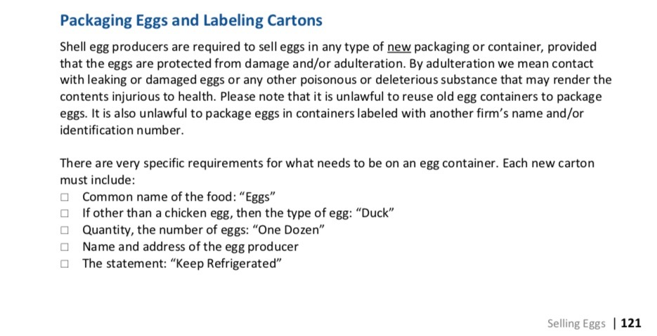
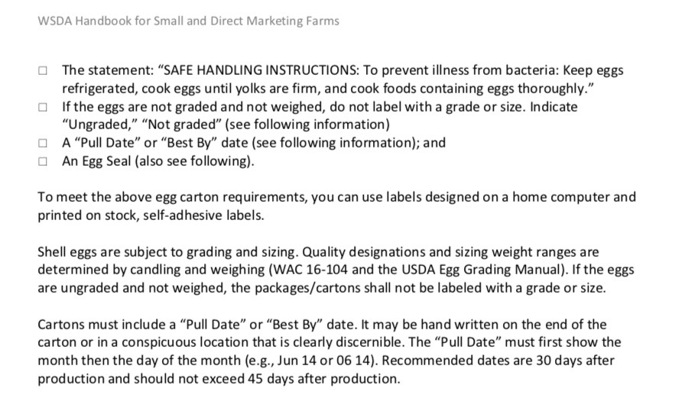
Honey: 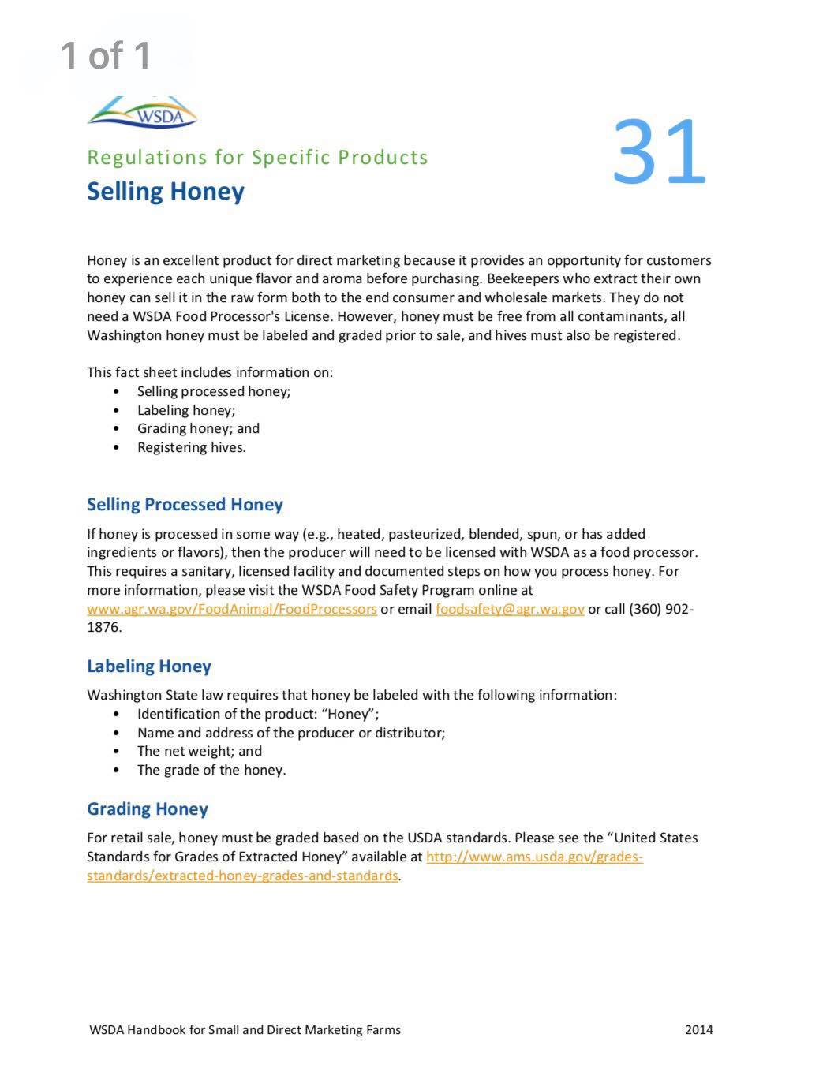
Canned Goods:
Washington cottage food law requires all canned goods, even jams and jellies, be made in a licensed kitchen. If you do not meet these requirements, or are an out of state vendor, please leave theses goods at home. Here is a link to the food laws:
https://agr.wa.gov/departments/food-safety/food-safety/cottage-food

Market Rules for Animal Sales
Animals must be free of parasites. Please treat for external parasites in the weeks before market with appropriate products. Diatomaceous Earth is NOT an effective treatment for external or internal parasites, you need to use an approved product for your species of animal. Check for body lice, mites and fleas. For rabbits also, check for ear mites and sore hocks. Goats & Sheep check for ear mites, mange, and internal parasites. A simple way to check for internal parasites in small ruminants is to look at the color of their inner eyelid, if anemic from parasites it will be pale.
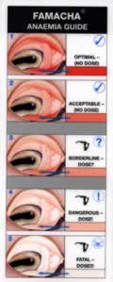
For poultry check for parasites around the head, neck and face, under the vent, wing band area, and the feet. Feet should not have bumblefoot. Check birds legs and feet for scaley leg mites.
Any bird with blood in its droppings or bright green or yellow loose stool cannot be sold. These are signs of coccidiosis, bacterial or fungal infections. Rabbits, cavies, pigs and ruminants should have formed stool, no diarrhea. All animals should be a healthy weight.
Bedding and supplies for animals at the event.
Animal vendors need to put down a new or clean and sterilized tarp to catch bedding and waste. Dirty tarps are not allowed due to biosecurity risk. If your tarp is dirty you will be asked to bag it up in a garbage bag and go purchase a new one. ALL WASTE must be packed out and disposed of elsewhere. Double D does not want bedding and animal waste in their garbage. Please bring a garbage bags for this purpose.
Hay and straw are not allowed for birds. Hay and straw create multiple health risks for birds. If ingested it can cause impaction or sour crop, hay and straw have a very hard time exiting the crop. Hay and straw mold and mildew quickly and the shafts are perfect parasite hotels. Pine shavings, hemp bedding, burlap bags, pine pellets and puppy pads are acceptable for birds. Ruminants may have straw for bedding. Rabbits need to have metal cages, carriers or secure x-pens. Bedding can be shavings, puppy pads, towels or fleece. Watch for chewing. All cages, crates and supplies should be cleaned and sanitized with bleach at a minimum. Cages and crates for poultry Virkon-S or ACTIVATED Oxine is strongly advised as bleach does not kill some poultry disease related bacteria. If you are selling used supplies at the event they also need to be cleaned and sanitized.
Food and Water
Animals must have constant access to food and water. Bring sufficient water for your animals as access to a water spigot is limited.
Handling of Animals
We recommend that you only let serious buyers touch your animals for sale to limit liability from potential injury and to maintain biosecurity. You are welcome to post signs that say, “No Touching” or “Please Ask For Help With Animals”.
Market Liability Disclaimer
Kalama Poultry and Small Animal Market is not liable for any injury or damages from vendor negligence.
Please Sign bellow to indicate you have read and accept the above:
Name: Date:

___________________________________ _________________

